**УО «Белорусский государственный университет информатики и радиоэлектроники»**

**Кафедра ПОИТ**

**Отчёт по лабораторной работе №3.1**

**По предмету**

**Основы алгоритмизации и программирования**

**Вариант 6**

**Выполнил:**

**Гладкий М.Г.**

**Проверила:**

**Данилова Г.В.**

**Группа 851001**

**Минск 2018**

**Задание:**

Дано целое число N>0 и строка S. Преобразовать строку S в строку длины N следующим образом: если длина строки S больше N, то отбросить первые символы, если длина строки S меньше N, то в ее начало добавить символы «.» (точка).

**Код Delphi 10:**

**program** Project9;

{$APPTYPE CONSOLE}

**uses**

SysUtils;

**const**

MinLength = 1;

MaxLength = 255;

**procedure** ChangeString(Num: Byte; **var** MyString: String);

**var**

i: Byte;

Leng : Integer;

**begin**

Leng := Length(MyString);

**if** Num > Leng **then**

**for** i := 1 **to** Num - Leng **do**

Insert('.', MyString, 1)

**else**

Delete(MyString, 1, Leng - Num);

**end**;

**function** ChoiceInput(): Char;

**var**

Input: Char;

IsCorrect: Boolean;

**begin**

**repeat**

Readln(Input);

Input := UpCase(Input);

**if** (Input = 'Y')**or**(Input = 'N') **then**

IsCorrect := true

**else**

**begin**

IsCorrect := false;

Write('Incorrect input. Enter Y(Yes) or N(No): ');

**end**;

**until** IsCorrect;

ChoiceInput := Input;

**end**;

**procedure** OutputConsole(MyString: String);

**begin**

Write('Changed string is: ');

Writeln(MyString);

**end**;

**procedure** ShowAnswerFile(**var** NewFile: TextFile; MyString: String);

**begin**

Write(NewFile, 'Changed string is: ');

Write(NewFile, MyString);

**end**;

**procedure** OutputFile(MyString: String);

**var**

IsCorrect: Boolean;

NewFile: TextFile;

NameOfFile: String;

**begin**

Write('Enter the name of file (.txt): ');

IsCorrect := false;

**repeat**

Readln(NameOfFile);

**if** (**not** FileExists(NameOfFile)) **then**

Write('File does not exist. Try again: ')

**else**

**begin**

IsCorrect := true;

Assign(NewFile, NameOfFile);

Write('Would you like to rewrite the file? Enter Y(Yes) or N(No): ');

**if** ChoiceInput = 'Y' **then**

**try**

Rewrite(NewFile);

ShowAnswerFile(NewFile, MyString);

**except**

Write('Access is not allowed. Try again: ');

IsCorrect:= false;

**end**

**else**

**try**

Append(NewFile);

ShowAnswerFile(NewFile, MyString);

**except**

Write('Access is not allowed. Try again: ');

IsCorrect:= false;

**end**;

**end**;

**until** IsCorrect;

Close(NewFile);

**end**;

**function** CheckLength(Min, Max: Byte): Byte;

**var**

Length: Integer;

IsCorrect: Boolean;

**begin**

IsCorrect := false;

**repeat**

**try**

Readln(Length);

**if** (Length >= Min) **and** (Length <= Max) **then**

IsCorrect := true

**else**

Writeln('Enter number from interval [', Min, '..', Max, ']: ');

**except**

Writeln('Check entered data. Enter number from interval [', Min, '..', Max,

']: ');

**end**;

**until** IsCorrect;

CheckLength := Length;

**end**;

**function** CheckLengthFile(Min, Max: Byte; **var** MyFile: TextFile): Byte;

**var**

Length: Integer;

IsCorrect: Boolean;

**begin**

IsCorrect := false;

**repeat**

**try**

Readln(MyFile, Length);

**if** (Length >= Min) **and** (Length <= Max) **then**

IsCorrect := true

**else**

Writeln('Enter number from interval [', Min, '..', Max, ']: ');

**except**

Writeln('Check entered data. Enter number from interval [', Min, '..', Max,

']: ');

**end**;

**until** IsCorrect;

CheckLengthFile := Length;

**end**;

**procedure** GetDataConsole(**var** Length: Byte; **var** MyString: String);

**begin**

Write('Enter N:');

Length := CheckLength(MinLength, MaxLength);

Write('Enter your string: ');

Readln(MyString);

**end**;

**procedure** ReadFromFile(**var** MyFile: TextFile; **var** Length: Byte; **var** MyString: String);

**begin**

Reset(MyFile);

Length := CheckLengthFile(MinLength, MaxLength, MyFile);

**while not** Eoln(MyFile) **do**

Read(MyFile, MyString);

**end**;

**procedure** GetDataFile(**var** Length: Byte; **var** MyString: String);

**var**

IsCorrect: Boolean;

NameOfFile: String;

MyFile: TextFile;

**begin**

Write('Enter file name(.txt): ');

**repeat**

Readln(NameOfFile);

**if** (**not** FileExists(NameOfFile)) **then**

**begin**

WriteLn('File does not exist. Try again: ');

IsCorrect := false;

**end**

**else**

**begin**

AssignFile(MyFile, NameOfFile);

Reset(MyFile);

**if** SeekEof(MyFile) **then**

**begin**

Writeln('File is empty. Try again: ');

IsCorrect := false;

**end**

**else**

**begin**

IsCorrect := true;

ReadFromFile(MyFile, Length, MyString);

**end**;

**end**;

**until** IsCorrect;

CloseFile(MyFile);

**end**;

**procedure** Main();

**var**

MyString: String;

Length: Byte;

**begin**

Writeln('This program converts the entered string into a string of length N as

follows:');

Writeln('If length of the string is greater than N, then discard the first characters,

if length of the string is less than N, then add points at the beginning.');

Write('Would you like to use File input instead of Console input?

Enter Y(Yes) or N(No): ');

**if** ChoiceInput = 'Y' **then**

GetDataFile(Length, MyString)

**else**

GetDataConsole(Length, MyString);

ChangeString(Length, MyString);

Write('Would you like to write down the answer to File instead of Console?

Enter Y(Yes) or N(No): ');

**if** ChoiceInput = 'Y' **then**

OutputFile(MyString)

**else**

OutputConsole(MyString);

Writeln('Press "Enter" to exit.');

Readln;

**end**;

**begin**

Main;

**end**.

**Скриншоты:**

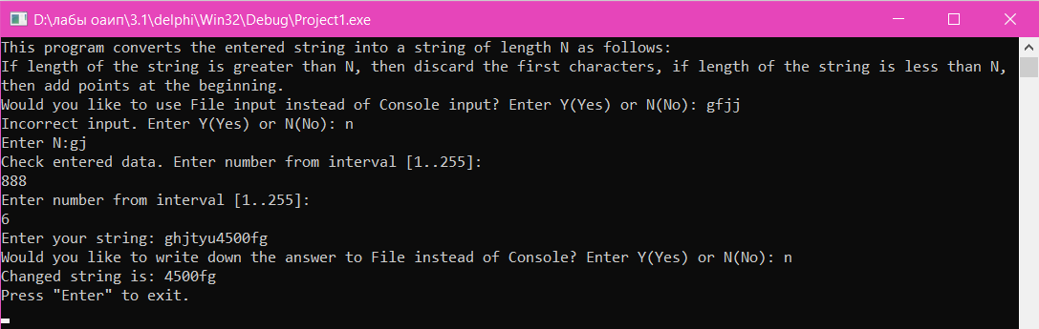

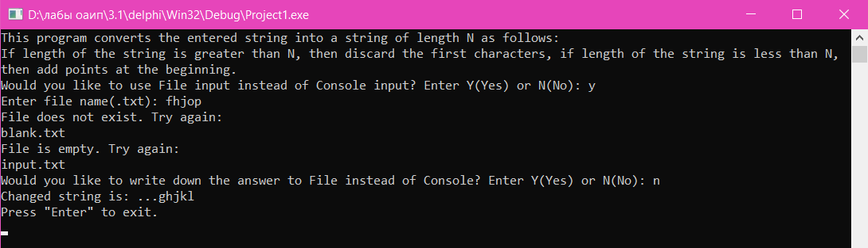

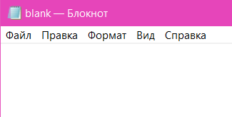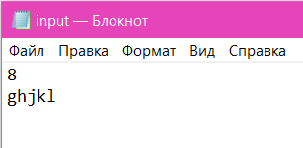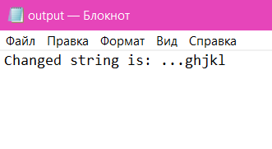

**Блок-схема:**





